Table of Contents
1 Probable Maximum Precipitation Estimation 3
2 Probable Maximum Flood (PMF) 11
2.1 DoED Recommended Method 11
2.2 Historical records 11
2.3 Unit Hydrograph Method 12
2.4 Rainfall-Runoff Modelling 15
2.4.1 Description of the Study Area 15
2.4.2 Materials and Methodology 16
2.4.3 Data Collection 16
2.4.4 Pre-processing in ArcGIS 16
2.4.5 Basin Model Setup 17
2.4.6 Meteorological Model 18
2.4.7 Time Series Data 19
2.4.8 Parameters selected 22
2.4.9 Results 23
2.5 Discussion 28
3 Annex 30
3.1 Calibration Event Data 30
3.2 Validation Event Data 31

Tables
Table 1-1 24-hr PMP computation using WMO statistical Hershfield method 7
Table 1-2: Hourly distribution of rainfall using 24 hr maximum rainfall value using (Shakya, 2002). 9
Table 1-3 Adopted Rainfall Temporal Pattern (24 Hr storm) 10
Table 2-1: 6-hours unit hydrograph abscissa and ordinates 13
Table 2-2 Catchment characteristics of Dam 5 16
Table 2-3 Meteorological stations collected for rainfall-runoff modeling 16
Table 2-4 Adopted Hydrological Elements 18
Table 2-5 Precipitation Time/Depth Weights for Middle Basin 19
Table 2-6 Precipitation Time/Depth Weights for Lower Basin 19
Table 2-7 Muskingum Routing Parameters 22
Table 2-8 Basin Loss Parameters 23
Table 2-9 Basin Flow Transform (Overland Flow) Parameters 23
Table 2-10 Basin Baseflow Parameters 23
Table 3-1 Selected data in the model for calibration event 30
Table 3-2 Model selected data for validation event 31
Figures
Figure 1-1 K_{m} value for the mean value of maximum rainfall series. 4
Figure 1-2 Adjustment of the mean of annual series for maximum observed rainfall 4
Figure 1-3 Adjustment of the standard deviation of annual series for maximum observed rainfall 5
Figure 1-4 Adjustment of the mean and standard deviation of annual series for length of the record 5
Figure 1-5 Depth-area or area-reduction curve 6
Figure 1-6 24-hour PMP distribution map in the project location. 8
Figure 1-7 Relationship between rain intensity and duration (Shakya, 2002) 9
Figure 2-1 Relationship between PMF and drainage area. 12
Figure 2-2 Synthetic Unit Hydrograph Ordinates for unit hydrograph 14
Figure 2-3 PMF at Dam 05 location considering PMP values of 467.9 mm of station Baglung (605). 15
Figure 2-4 Basin model for Kaligandaki basin 18
Figure 2-5 Incremental Rainfall Data for Baglung (Calibration) 20
Figure 2-6 Incremental Rainfall Data for Jomsom (Calibration) 21
Figure 2-7 Incremental Rainfall Data for Baglung (Validation) 21
Figure 2-8 Incremental Rainfall Data for Jomsom (Validation) 21
Figure 2-9 AWLR Observed Flow Hydrograph (Calibration event) 22
Figure 2-10 AWLR Observed Flow Hydrograph (Validation event) 22
Figure 2-11 Observed and modeled flows during calibration 24
Figure 2-12 Summary table for the calibrated event 24
Figure 2-13 Observed and modelled flows during validation 25
Figure 2-14 Summary table for the validation event 25
Figure 2-15 Flow hydrograph for PMF estimation with max precipitation recorded in both station Baglung and Jomsom 26
Figure 2-16 Summary table for the PMF estimation with max precipitation recorded in both station Baglung and Jomsom 26
Figure 2-17 Flow Hydrograph for PMF estimation with max precipitation recorded only in station Baglung 27
Figure 2-18 Summary Table for PMF estimation with max precipitation recorded only in station Baglung 28
Figure 2-19 World’s Largest Floods Envelope Curves 29

Probable Maximum Precipitation Estimation
The objective of probable maximum precipitation (PMP) estimate is to calculate the probable maximum flood (PMF) used in the design of a given project at a particular geographical location in a given watershed and to further provide information that could assist in designing the size (dam height and reservoir storage capacity) of the given project and dimension of the flood-carrying structures (spillway and flood-carrying tunnel) of the project. PMP is the theoretical maximum precipitation for a given duration under modern meteorological conditions. PMP estimation in this study has been carried out using the statistical procedure as mentioned in the manual of WMO.
Out of many rainfall stations available in the project area, the stations with more than 35 years of available rainfall daily data were adopted for the calculation of PMP in this study. The selected station for the study of PMP is 604, 605, 607, 609, 613, 817, 818, and 824. The stations above 5000 m masl elevation are not considered in the study as the precipitation above 5000 m masl generally occurs in the form of snow. The study is carried out by using the statistical estimation method for deriving the probable maximum precipitation value. While this method is a frequency analysis method, the procedure is only used when sufficient precipitation data is available.
The procedure developed by Hershfield is based on the general frequency equation and follows the following procedure.
$$X_{m}=Xn+K_{m} S_{n}$$
Where,
$X_{m}$ is the maximum observed rainfall for return period t, $Xn$ and $S_{n}$ is the mean and standard deviation of a series of n annual maxima and Km is a common statistical variable, that varies with the different frequency distribution fitting extreme value hydrological data.
The calculated $Xn$ and $S_{n}$ values for observed annual maximum series are adjusted by calculating $X_{n-m}$ and $S_{n-m}$ which are the mean and standard deviation of the annual series computed after excluding the maximum item in the series considering the maximum value to be a rare event. An adjustment was also made for the length of the record. The calculated PMP value is also adjusted for the hourly duration and for the area to be affected by the calculated probable maximum precipitation value. The graphs that have been used for considering the adjustment factors are given in Figure 1-1, Figure 1-2, Figure 1-3, Figure 1-4, and Figure 1-5.
The step-by-step procedure is described in Chapter 4 of the WMO manual on the estimation of Probable Maximum Precipitation.
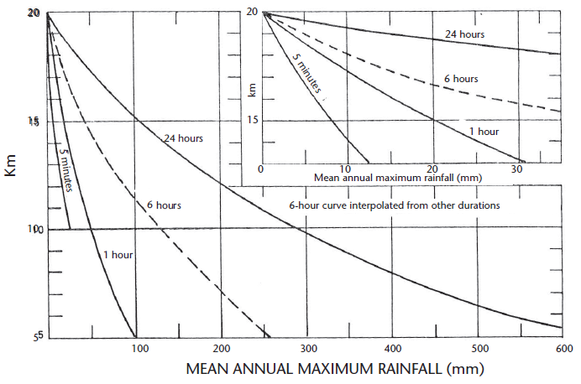
Figure 1-1 K_{m} value for the mean value of maximum rainfall series.
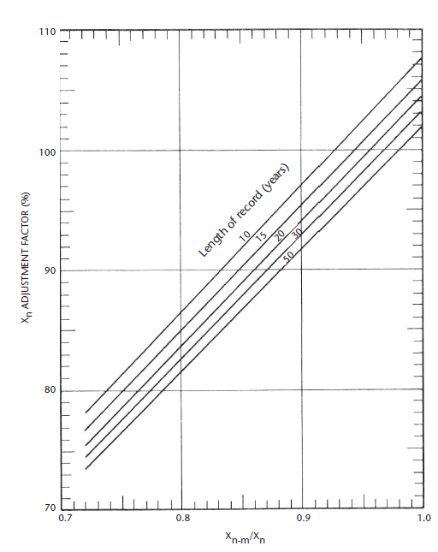
Figure 1-2 Adjustment of the mean of annual series for maximum observed rainfall
Figure 1-3 Adjustment of the standard deviation of annual series for maximum observed rainfall
Figure 1-4 Adjustment of the mean and standard deviation of annual series for length of the record
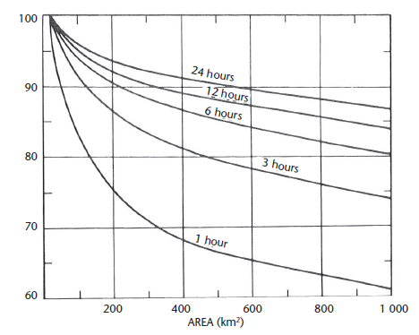
Figure 1-5 Depth-area or area-reduction curve
The adopted areal reduction factor has been used to reduce the calculated point PMP value to the proper areal value for the size of the basin.
Table 1-1 presents the PMP values obtained from WMO PMP estimation guidelines for provided eight stations. The maximum value of the PMP of 951.8 mm is seen to be obtained in station 817 located at Damauli Tanahun which is not within the catchment of hydrological station 410. The meteorological station 604 which lies within about the centre of the basin is expected to receive PMP of value 434 mm. However, the maximum recorded precipitation value within 53 years of daily data is 86.6 mm. Therefore, the PMP value is considered to be over-estimated for the given station. The lowest difference between maximum precipitation value that has been received and calculated PMP is seen in station 605 located at Baglung for a period of 52 years, the station lies fairly close to the hydrological station 410 and dam site. Given these facts, the PMP value of this station which is 526.4 mm is selected as the probable maximum precipitation value that can be received in the catchment with 24 hours and thus when routed can cause probable maximum flood for the project components.

Table 1-1 24-hr PMP computation using WMO statistical Hershfield method
S.N | Computation of Probable Maximum Precipitation
S.N | Parameters | Station number
S.N | Parameters | 601 | 604 | 605 | 607 | 609 | 613 | 817 | 818 | 824
1 | Number of years (N) | 53 | 53 | 50 | 52 | 60 | 44 | 47 | 49 | 44
2 | Mean
 | Including all values, Xn | 37.63 | 39.12 | 96.92 | 64.88 | 78.90 | 117.20 | 122.37 | 177.82 | 140.99
 | Excluding maximum value, X(n-m) | 36.65 | 38.21 | 94.64 | 62.71 | 76.64 | 115.00 | 116.67 | 174.63 | 138.52
3 | Standard Deviation
 | Including all values, Sn | 22.51 | 19.99 | 30.75 | 27.93 | 34.70 | 31.61 | 56.80 | 53.30 | 39.02
 | Excluding maximum value, Sn-m | 21.57 | 19.05 | 26.56 | 23.14 | 30.30 | 28.44 | 42.11 | 48.40 | 35.41
4 | Km | 18.50 | 18.5 | 15.2 | 17.0 | 16.5 | 14.5 | 14.0 | 13.0 | 13.5
5 | X(n-m) /Xn | 0.97 | 0.98 | 0.98 | 0.97 | 0.97 | 0.98 | 0.95 | 0.98 | 0.98
6 | S(n-m)/Sn | 0.96 | 0.95 | 0.86 | 0.83 | 0.87 | 0.90 | 0.95 | 0.91 | 0.91
7 | Adjustement factor for Xn | 1.00 | 1.00 | 1.00 | 0.92 | 1.02 | 1.02 | 1.02 | 1.02 | 1.02
8 | Adjustment factor for Sn | 1.10 | 1.05 | 0.90 | 1.10 | 1.05 | 1.00 | 1.02 | 1.00 | 1.05
9 | Adjusted mean | 37.63 | 39.12 | 96.92 | 59.69 | 80.48 | 119.54 | 124.81 | 181.37 | 143.81
10 | Adjusted Standard Deviation | 24.76 | 20.99 | 27.68 | 30.72 | 36.44 | 31.61 | 57.93 | 53.30 | 40.97
11 | 24-hr PMP value | 495.71 | 427.40 | 517.58 | 581.95 | 681.67 | 577.90 | 935.86 | 874.31 | 696.93
12 | Adjustment factor for hourly data to 24 hr true maximum | 1.13 | 1.13 | 1.13 | 1.13 | 1.13 | 1.13 | 1.13 | 1.13 | 1.13
13 | Area Reduction Factor for adjustment of point PMP | 0.8 | 0.8 | 0.8 | 0.8 | 0.8 | 0.8 | 0.8 | 0.8 | 0.8
14 | 24-hr PMP adjusted | 448.1 | 386.4 | 467.9 | 526.1 | 616.2 | 522.4 | 846.0 | 790.4 | 630.0
15 | Maximum recorded daily precipitation value | 88.8 | 86.6 | 208.5 | 175.5 | 212.2 | 211.90 | 384.20 | 331.00 | 247.20

The isolines for the 24-hr PMP values estimated in the project location are given in Figure 1-6.

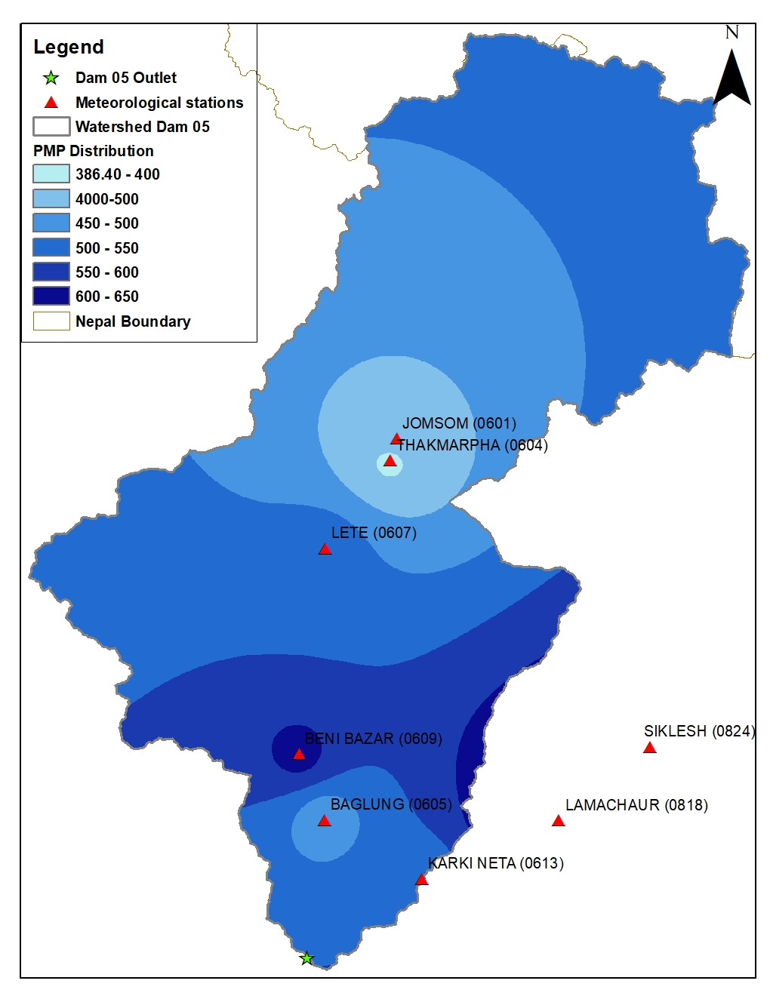
Figure 1-6 24-hour PMP distribution map in the project location.
The PMP values derived from the procedure contained in the WMO manual are regionalized by preparing isolines using the isohyetal method. The isolines of 24-hr PMP are given on a map as shown in the figure allows the determination of storm-related PMP over a region within the limits set on area and duration. DHM has recorded a maximum of 24 hr rainfall in the project area thus the estimated PMP value is of 24 hr recorded major storms.
Rainfall data in Nepal are generally collected by simple non-recording rain gauges thus hourly intensities are not available. The hourly rainfall values can be determined as
$$H_{hr}= K_{hr}×H_{24-hr max}$$
Where, K_{hr} is the transfer coefficient from 24-hour maximum rainfall to 1- hour maximum rainfall
This coefficient can be estimated properly if the data is available on both 24-hr maximum and hourly maximum rainfall.
Shakya (2002) has developed the relationship between 24 hours and lower-duration precipitation depths developed from hourly rainfall data for specified storm periods using the data from the few automatic stations within Nepal. The best-fitted equation is
$$\frac{P_{t}}{P_{24}}=Sin{(\frac{π. t}{48})}^{0.4727}$$
Where Pt is rainfall amount in t hours, P24 is the total rainfall amount in 24 hours.
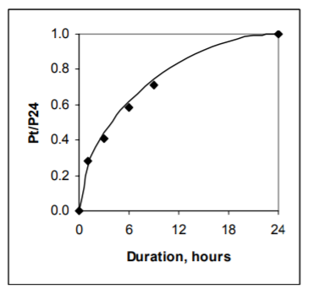
Figure 1-7 Relationship between rain intensity and duration (Shakya, 2002)
Using the above equation, the hourly distribution of rainfall is calculated. The rainfall has been arranged such that the rainfall follows an increasing trend until it reaches a maximum at the middle of the storm period and thus decreases after the maximum occurrence. Asserting that PMP is an unusually large event, it is unnecessary to adopt extreme initial conditions for the calculation of PMF. Given that the flood/storm that results in PMF/PMP is very large, antecedent rainfall and base flow have less effect on PMF values. Thus, retention loss of 1 mm/hr is only assumed to determine the effective precipitation value.
Table 1-2: Hourly distribution of rainfall using 24 hr maximum rainfall value using (Shakya, 2002).
Time in hours | Percentage of maximum precipitation (Pt/P24) | p(t) | Arranging | Order | Hourly Precipitation (mm) | Retention loss  (mm/hr) | Effective precipitation
1 | 0.28 | 27.55% | 0.51% | 22 | 2.67 | 1 | 1.67
2 | 0.38 | 10.64% | 0.92% | 20 | 4.84 | 1 | 3.84
3 | 0.46 | 7.99% | 1.34% | 18 | 7.06 | 1 | 6.06
4 | 0.53 | 6.60% | 1.78% | 16 | 9.38 | 1 | 8.38
5 | 0.58 | 5.69% | 2.25% | 14 | 11.84 | 1 | 10.84
6 | 0.64 | 5.03% | 2.76% | 12 | 14.53 | 1 | 13.53
7 | 0.68 | 4.50% | 3.35% | 10 | 17.61 | 1 | 16.61
8 | 0.72 | 4.06% | 4.06% | 8 | 21.37 | 1 | 20.37
9 | 0.76 | 3.68% | 5.03% | 6 | 26.45 | 1 | 25.45
10 | 0.79 | 3.35% | 6.60% | 4 | 34.75 | 1 | 33.75
11 | 0.82 | 3.04% | 10.64% | 2 | 56.02 | 1 | 55.02
12 | 0.85 | 2.76% | 27.55% | 1 | 145.02 | 1 | 144.02
13 | 0.87 | 2.50% | 7.99% | 3 | 42.06 | 1 | 41.06
14 | 0.90 | 2.25% | 5.69% | 5 | 29.97 | 1 | 28.97
15 | 0.92 | 2.01% | 4.50% | 7 | 23.67 | 1 | 22.67
16 | 0.93 | 1.78% | 3.68% | 9 | 19.37 | 1 | 18.37
17 | 0.95 | 1.56% | 3.04% | 11 | 16.01 | 1 | 15.01
18 | 0.96 | 1.34% | 2.50% | 13 | 13.15 | 1 | 12.15
19 | 0.97 | 1.13% | 2.01% | 15 | 10.58 | 1 | 9.58
20 | 0.98 | 0.92% | 1.56% | 17 | 8.20 | 1 | 7.20
21 | 0.99 | 0.71% | 1.13% | 19 | 5.94 | 1 | 4.94
22 | 1.00 | 0.51% | 0.71% | 21 | 3.75 | 1 | 2.75
23 | 1.00 | 0.30% | 0.30% | 23 | 1.60 | 1 | 0.60
24 | 1.00 | 0.10% | 0.10% | 24 | 0.53 | 1 | 0.00
The provided temporal distribution shall thus be used in the computation of the flood hydrograph for the PMP value.
The 24-hr temporal distribution pattern of the rainfall was improved by considering the temporal pattern more realistic as in the previous distribution the concentration of the rainfall is significant over a short period. Thus the newly adopted temporal pattern for 24 hr PMP storm is given in Table 1-1.
Table 1-3 Adopted Rainfall Temporal Pattern (24 Hr storm)
Baglung station (605) |  |  | Jomsom Station (601)
Time in hours | Hourly Precipitation (mm) | 6-h Hourly Precipitation (mm) | Time in hours | Hourly Precipitation (mm) | 6-h Hourly Precipitation (mm)
3 | 6.63% | 31.02 | 3 | 6.63% | 29.71
6 | 11.98% | 56.05 | 6 | 11.98% | 53.68
9 | 15.09% | 70.60 | 9 | 15.09% | 67.62
12 | 19.25% | 90.07 | 12 | 19.25% | 86.26
15 | 17.25% | 80.71 | 15 | 17.25% | 77.30
18 | 11.99% | 56.10 | 18 | 11.99% | 53.73
21 | 10.88% | 50.91 | 21 | 10.88% | 48.76
24 | 6.93% | 32.42 | 24 | 6.93% | 31.05

Probable Maximum Flood (PMF)
PMF is the theoretical maximum flood in the watershed. It is expected from the most severe combination of meteorological and hydrological conditions that is possible in a drainage area. Uncontrolled floodwaters are destructive in nature and hydraulic structures that are not designed to withstand them can be destroyed. Due to the complexity of phenomena and limitations in the data only the approximation method is adopted for the calculation of PMP. There are several methods used for the calculation of PMF. Some of them are given below:

DoED Recommended Method
PMF can be taken as twice the 10,000 years return period flood when there is not enough and reliable data available for the estimation of PMF. The 10,000 years flood for the dam site (5) as estimated is 5,535.57 m³/s. Thus, PMF = 2 x 5,535.57= 11,070.74 m³/s.

Historical records
Historical records of PMF in several hydropower and irrigation projects within the different watershed of Nepal and India has been used to identify the relationship between peak floods and drainage area of the catchment. The recorded flood values have been collected for the catchment ranging between 126 to 42,725 km². The given method has already been used in Kaligandaki A Hydroelectric Project (KG-A HEP) of 144 MW. The reference has been taken from KG-A HEP Project formulation report II (1993) published by Norconsult International, Norway. The report states that PMF in a catchment is based on the regional relationship between PMF and drainage area below 3600 masl, which is conservative. However, the study by DHM (Department of Hydrology and Meteorology) for ungauged basins states that the portion of the basin below 3000 m elevation is highly influenced by monsoon precipitation.
The collected data on PMF and drainage area is given in Figure 2-1.
The envelope curve equation developed from the given recorded flood shows a good correlation of 0.85 and is given as:
$y=158×A^{-0.46323}$ (1)
Where, y is the ratio of PMF (m³/s) to catchment area (km²) and A is the catchment area (km²).

Figure 2-1 Relationship between PMF and drainage area.
The relationship between PMF and the drainage area as given from the above figure was used for the calculation of the PMF in the dam site of the KG-A Hydroelectric Project. The drainage area of the Dam site of KG-A as mentioned in the project formulation report II is 3,250 km² and the corresponding PMF from the above-given equation is 12,126 m³/s. The area of the catchment at Dam-05 below the elevation of 3600 amsl is 2,755.68 km². Applying this relationship, the PMF discharge is estimated to be 11,100 m³/s. However, if the whole catchment to Kaligandaki Dam site is applied the PMF is 18,060 m³/s.

Unit Hydrograph Method
Snyder’s synthetic unit hydrograph method was used for the estimation of PMF from the calculated PMP value as given above using Hershfield’s method. A synthetic unit hydrograph is derived from theory and experience, and its purpose is to simulate basin diffusion by estimating the basin lag based on a certain formula or procedure. It is based on relationships found between three characteristics of a standard unit hydrograph and descriptors of basin morphology. The basin properties like the length of the stream, distance from the outlet of the watershed to the nearest centroid of watershed area, the total area of the basin, and the area below specific elevations were all derived from GIS.
A specific event of rainfall recorded by AWS near Dam location and discharge in the river on the same day was used for estimation of the lag time. The selected event was on date 5/31/2021 with an effective 1 hr rainfall value of 11.6 mm. The recorded gauge in the AWLR was converted to discharge value using the established rating curve equation. The lag time considering the given event was found to be about 8 hrs.
The time parameter Ct and peak parameter Cp were then derived. We know that a larger Ct meant a greater basin lag and, consequently, greater diffusion. A larger Cp meant a greater peak flow and, consequently, less diffusion.
Some of the formulas that have been used in the process are given in the text below.
Basin lag time from specific rainfall duration:
$$t_{l}=5.5 t_{r}$$
Time parameter Cp:
$C_{p}=\frac{q_{p}×t_{l}}{C_{2 }×A}$Where C₂ is coefficient of value 2.75 adopted for the method using literature
A is the basin area in km²
q_{p} is the peak direct runoff rate derived from observe discharge value
As these parameters were identified, the hydrograph was derived. Assuming a triangular shape for the UH, and given that the UH represents a direct runoff volume of 1 cm (1 in), the base time of the required UH may be estimated by,
$t_{b}= \frac{C3 ×A}{q_{p}}$ where C₃ is 5.56
The time to peak t_{p} is calculated as
t_{p} = t_{R}/2+ t_{lr}
As an aid in drawing an adequate UH, the U.S. Army Corps of Engineers developed relationships for the widths of the UH at values of 50% (W₅₀) and 75% (W₇₅) of q_{p}. The width in hours of the UH at a discharge equal to a certain percent of the peak discharge q_{p} is given by Chow et al. (1988) as,
$$W\% = C_{w}×{\left(\frac{q_{p}}{A}\right)}^{1.08}$$
where the constant Cw is 1.22 (440 for English units) for the 75% width and equal to 2.14 (770 for English units) for the 50% width. Usually, one-third of this width is distributed before the peak time and two-thirds after the peak time, as recommended by the U.S. Army Corps of Engineers.
The distributed 6-h discharge unit hydrograph ordinate for the is given in Table 2-1.
Table 2-1: 6-hours unit hydrograph abscissa and ordinates
6-h unit flow hydrograph

Time (hr) | Discharge (m³/s)
0 | 0
3 | 65.2
6 | 130.4
9 | 195.5
12 | 262.0
15 | 322.8
18 | 373.1
21 | 398.2
24 | 373.1
27 | 348.0
30 | 322.8
33 | 295.3
36 | 262.0
39 | 228.7
42 | 197.8
45 | 174.9
48 | 152.0
51 | 129.1
54 | 106.2
57 | 83.3
60 | 60.4
63 | 37.4
66 | 14.5
69 | 0.0

Figure 2-2 Synthetic Unit Hydrograph Ordinates for unit hydrograph
The calculated PMF value using adopted hourly distributed rainfall as given in Table 1-3, ordinates of UH, and constant loss of 0.1 cm, the PMF was calculated. The PMF value using the above unit hydrograph method was estimated to be 14,776 m³/s.

Figure 2-3 PMF at Dam 05 location considering PMP values of 467.9 mm of station Baglung (605).

Rainfall-Runoff Modelling
Hydrological modelling is a commonly used tool to simulate the hydrological response in a basin due to precipitation. Estimation of surface runoff in a watershed based on the rate of received precipitation and quantifying discharge at the outlet is important in hydrologic studies. An analysis has been done for developing a Hydrological Model for the calculation of Probable Maximum Flood (PMF) using Probable Maximum Precipitation (PMP), over a Watershed. The rainfall-runoff modelling was carried out in HEC-HMS using the specific event of precipitation. The focus of the study is firmly on PMP estimates derived through Statistical Approach as mentioned in the WMO guidelines. To compute loss, rainfall excess conversion to runoff, base flow, and flow routing, methods like SCS curve number, Snyder’s Unit hydrograph, recession, and Muskingum routing were chosen, respectively. the methods describe the methodology for portraying the PMP estimation for the Kaligandaki basin at Dam location 5. The DEMs of the study area were processed using ArcGIS for catchment delineation, terrain processing and basin processing.

Description of the Study Area
The present study deals with the hydrological modelling for the watershed area of Dam 5 for the Kaligandaki Storage Hydropower Project. The catchment area of the dam is estimated to be 6828.37 km². The description of the catchment area at Dam 5 is given in Table 2-2. The Kaligandaki River Basin is an important sub-basin of the Gandaki (Narayani) Basin located between 27° 43′N to 29° 19′N and 82° 53′E to 84° 26′E.in Nepal. The Himalayan zone contributes to the streamflow in the dry season by snow and ice melt. The highest percentile area within the catchment includes The Central Mahabharat Zone which contributes most to the high flows in the monsoon. This region is also responsible for the highest sediment yields due to steep topography and deforestation.

Table 2-2 Catchment characteristics of Dam 5
Features | Unit | Dam -5
Features | Unit | Area | Percentage (%)
Total Catchment Area (A) | km² | 6828.37 | 100
Area above 5000 m | km² | 1976.99 | 28.95
The area between 3000 to 5000 m | km² | 2771.77 | 40.59
Area below 3000 m | km² | 2079.60 | 30.46

Materials and Methodology
The methodology for the model setup was divided into parts.
- Data collection
- Pre-processing in ArcGIS
- Model setup

Data Collection
In this study, an attempt to collect the relevant rainfall and discharge data with a temporal resolution of an hour was made. Rainfall hourly data were collected from the Department of Hydrology and Meteorology (DHM). The gauge data is recorded every 15 min in an Automatic Water Level Recording (AWLR) device installed in Purtighat which has been used in this study by converting it into discharge value using the rating curve equation. The available station and the period of availability are given in Table 2-3.
Table 2-3 Meteorological stations collected for rainfall-runoff modeling
S. No. | Station Number | Station Name | Range of data of the availability | Longitude  DD.MM | Latitude  DD.MM | Elevation
Meteorological Stations
1 | 601 | Jomsom | 10/21/2020 9:00  – 7/8/2021 23:59 | 83.43 | 28.47 | 2,744
2 | 604 | Thakmarpha | 2/3/2020 14:00  – 7/8/2021 23:59 | 83.7 | 28.75 | 2566
3 | 605 | Baglung | 9/11/2020 00:00  – 7/8/2021 23:59 | 83.6 | 28.26 | 984
The AWLR has been operating and thus the corresponding gauge data were downloaded from the website WSCADA where data is transmitted in real-time. The gauge data were converted to discharge to be used as observed discharge in the model.
SRTM DEM of 30 m x 30 m spatial resolution was acquired and trimmed for the KGSHPP catchment (previously computed in hydrological calculations).

Pre-processing in ArcGIS
The trimmed DEM was projected to MUTM 84 Projected Coordinate System and filled for pits using the “Fill” tool under Hydrology of Spatial Analyst tools. The DEM was exported and the catchment was delineated in HEC-HMS so that the outlet can be assigned at Dam location 05. The basin model was named “Kaligandaki Basin” in HEC-HMS.
For the SCS CN loss-model of sub-basins, land-use map for KGSHPP was analysed for area distribution and curve numbers based on the dominance of area-by-land-use were adopted for each basin (Middle and Lower).

Basin Model Setup
A new model in HEC-HMS consists of three main parts; a basin model, meteorological model, and control indices. A basin model was then created and the terrain file was linked. The coordinate system for Basin Model Grid was adopted from the imported georeferenced terrain. A breakpoint was defined at the lowermost outlet point obtained from GIS. Drainage pre-processing was done and streams were identified for the condition A > 300 km². An automated delineation of elements was performed using HEC-HMS. While the automatic delineation divided the catchment into more than 10 new sub-catchments, these were merged to a coarser 3 sub-catchment set up to comply with sparsely available meteorological data. The model is not divided into detailed sub catchments as data available is limited and better calibration and validation is performed in a lumped basin model with only 3 sub catchments.
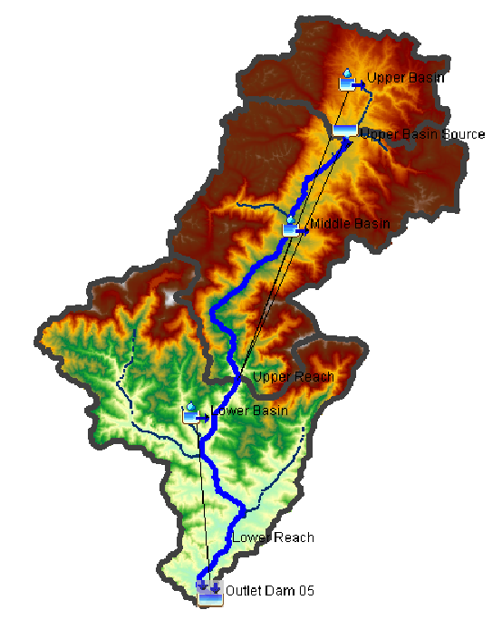
Figure 2-4 Basin model for Kaligandaki basin
The basin elements chosen for the model are as enlisted in hydrological order:
Table 2-4 Adopted Hydrological Elements
SN | Hydrological Element | Element Type | Downstream Link Element | Catchment Area (km²)
1 | Upper Basin | Sub-basin | Upper Reach | 1021.4
2 | Upper Basin Source | Source | Upper Reach | -
3 | Upper Reach | Reach | Lower Reach | -
4 | Middle Basin | Sub-basin | Lower Reach | 2905.8
5 | Lower Reach | Reach | Sink-1 | -
6 | Lower Basin | Sub-basin | Sink-1 | 2875.74
7 | Sink-1 | Sink | - | -
The “Upper Basin” was set up simply to retain the “Upper Reach” element as merging of upper and middle basins forced the same parameters to be used for both the basin. It was stipulated that input to the “Lower Reach” by simply overland flow over the middle and upper basin would be insufficient to calibrate the basins based on flow peak events. However, no rainfall event, overland flow, or channel routing was devised for this sub-catchment.
The “Upper Basin Source” source was set up as a “Constant inflow” source. This was used for representing the expected contribution from the entire “Upper basin” catchment including snow-melt and the runoff from rainfall whose data were not available. It was set up in this manner owing that the model is not used for snowmelt calculations. The value for this constant discharge was optimized during the calibration stage and set to 300 m³/s.
Both the “Upper Reach” and “Lower Reach” were modelled to be routed by the Muskingum method. The parameters were adopted as tabulated in Table 2-7. No loss/gain method was defined for the reaches owing to the peak damping coefficient available within the Muskingum method. These values were calibrated to match the peak timings from observed data at AWLR.

Meteorological Model
A new meteorological model was created and named “Rainfall”. Precipitation was defined using the “Gauge Weights” method owing to the sparse distribution of rain gauges with available hourly data for the model. The rain gauge stations that can be used for the sub-catchments were identified. Spatial distribution of recorded rainfall data in the Kaligandaki basin using Thiessen polygon method catchment was not suitable as only three rain gauges with a temporal resolution of an hour are available in the entire catchment. “Thakmarpha” station data was also available but discarded as it was adjacent to “Jomsom” station for the scale of the division of sub-catchment considered for this model. Also, the data overlap for “Selected Event” suited Jomsom better for calibration.
The gauge data for rainfall were defined for meteorological stations, conforming to the run-time of “Selected Event”. The following stations were considered:
- Baglung
- Jomsom
The time and depth weights for “Lower” and “Middle” basins were calibrated based on the trend (slope steepness) of Recession Limb for early (“Jomsom Rainfall” for Middle Basin) and late (“Baglung Rainfall” for Lower Basin) from computed hydrograph at Sink-1. A separate weight value for the rain gauge was provided during validation as the rainfall weights are event-dependent.
The adopted weights for Middle Basin and Lower Basin during calibration and validation are as tabulated in Table 2-5 and Table 2-6.
Table 2-5 Precipitation Time/Depth Weights for Middle Basin
Precipitation Event (Gauge) | Calibration |  | Validation
Precipitation Event (Gauge) | Depth Weight | Time Weight | Depth Weight | Time Weight
Jomsom | 1 | 1 | .1 | .1

Table 2-6 Precipitation Time/Depth Weights for Lower Basin
Precipitation Event (Gauge) | Calibration |  | Validation
Precipitation Event (Gauge) | Depth Weight | Time Weight | Depth Weight | Time Weight
Baglung | 0.5 | 0.5 | 1 | 1
Jomsom | 1 | 1 | 0.1 | 0.1

Time Series Data
Station Thakmarpha and Jomsom lie adjacent to each other. Thus, only the Jomsom station was used for the model thus representing the rain gauge in the middle basin. Station Baglung was used for the lower basin.
The meteorological models were defined in the model for separately selected rainfall events for validation and calibration. The event selection for the calibration and validation of the model was carried out with careful observation. The main idea was to capture the behaviour of the catchment for the peak event, selected rainfall event includes the time duration when both the stations Jomsom and Baglung have rainfall on the higher side. “Baglung” had an earlier rainfall event than rainfall at “Jomsom” station. This data format was selected so that the individual peaks could be calibrated in order of “Lower Basin Parameters” with “Baglung” and “Middle Basin Parameters” with “Jomsom”. This includes the period between 6/14/2021 00:00 to 6/17/2021 00:00 for calibration of the model. For the validation, rainfall event between 07/05/2021 15:00 to 07/06/2021 18:00 was chosen. This event was considered as an isolated event as the preceding event rainfall was allowed to recede to base flow before a new rainfall event was received in the catchment. The validation event was not intended for simulating the highest rainfall event but just to confirm the performance of the calibrated model. The selected rainfall event graph for validation and calibration are given in the figures below:
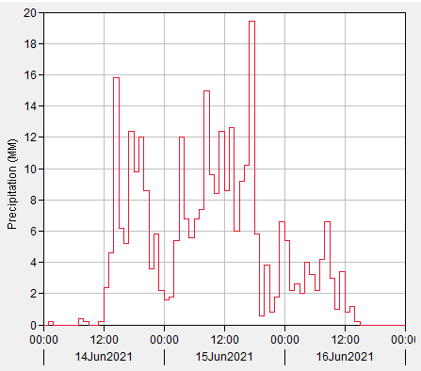
Figure 2-5 Incremental Rainfall Data for Baglung (Calibration)
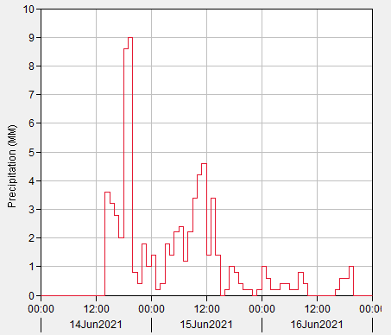

Figure 2-6 Incremental Rainfall Data for Jomsom (Calibration)

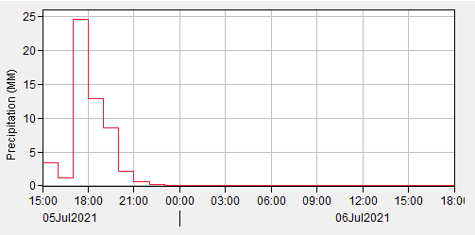
Figure 2-7 Incremental Rainfall Data for Baglung (Validation)
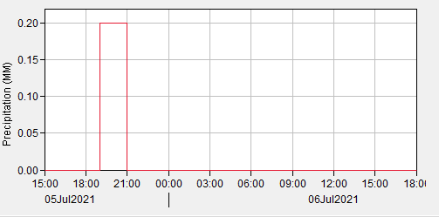
Figure 2-8 Incremental Rainfall Data for Jomsom (Validation)
The table for the selected rainfall event and corresponding discharge in the river is added in the annex.
The Sink-1 (Outlet at Dam 05) was set with the observed flow at AWLR (Automation Water Level Recorded) setup at KGSHPP. The data was added as time-series data with a defined Control Specification. The event recorded from 14 June 2021 00:00 to 17 June 2021 00:00 was set up as “Selected Event” under the control specification manager for calibration event.
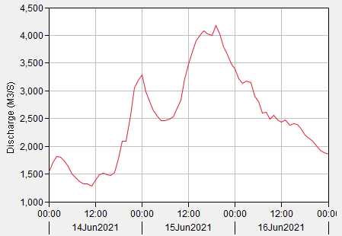
Figure 2-9 AWLR Observed Flow Hydrograph (Calibration event)
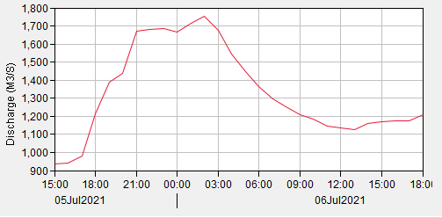
Figure 2-10 AWLR Observed Flow Hydrograph (Validation event)

Parameters selected
Several optimization trials were computed for determining the parameters in the calibration stage. The most sensitive parameters selected during the optimization trials and other parameters were locked. The model was calibrated to match recorded hourly flow in AWLR.
Table 2-7 Muskingum Routing Parameters
Reach | Muskingum K (Hr) | Muskingum X
Upper | 2.0106 | 0.20686
Lower | 2.5011 | 0.24109
Both the “Middle Basin” and “Lower Basin” were modelled

for:
- Losses using SCS Curve Number Method
- Flow Transform using Snyder Unit Hydrograph Method
- Baseflow using Recession Method
The tabulated parameters for each process are as tabulated.
Table 2-8 Basin Loss Parameters
Sub-basin | Initial Abstraction | Curve Number | Impervious (%)
Middle | 5.3224 | 70.361 | 0.0
Lower | 12.167 | 54.695 | 5.0

Table 2-9 Basin Flow Transform (Overland Flow) Parameters
Sub-basin | Standard Lag (Hr) | Peaking Coefficient
Middle | 4.3621 | 0.54999
Lower | 4.446 | 0.41011
Table 2-10 Basin Baseflow Parameters
Sub-basin | Initial Discharge (m³/s) | Recession Constant | Threshold Type | Ratio
Middle | 397.92 | 0.80 | Ratio to Peak | 0.59
Lower | 479.19 | 0.95 | Ratio to Peak | 0.56
The initial base flow discharges were distributed to fit the observed discharge such that the flow from “Upper Basin Source”, and initial discharges of the “Middle” and “Lower” basins could sum up to the observed discharge at the start of the selected Rainfall-Runoff event.

Results
- Calibration:
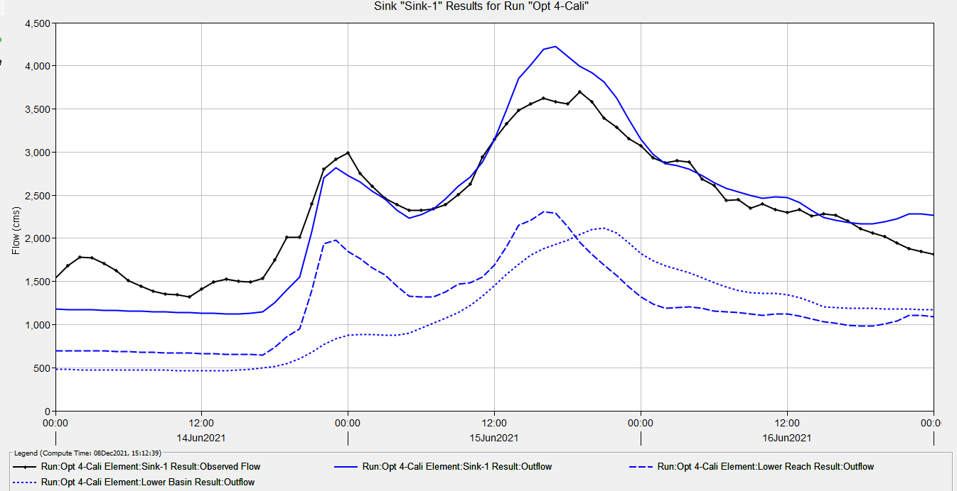
The model for KGSHP was prepared and calibrated in HEC-HMS. The flow at the outlet of Dam 05 “Sink-01” and “Observed Flow at AWLR” can be observed in Figure 2-11. The Summary table for the calibrated model simulation is given in Figure 2-12.
Figure 2-11 Observed and modelled flows during calibration
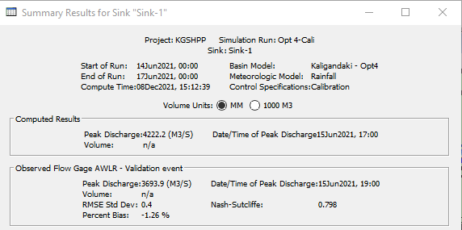
Figure 2-12 Summary table for the calibrated event
- Validation
The calibrated model for KGSHP was run for a validation event. The simulated flow at “Dam 05” and “Observed Flow at AWLR” for the validation event can be observed in Figure 2-11. The Summary table for the calibrated model simulation is given in Figure 2-12
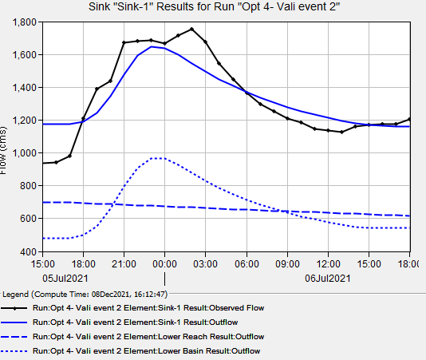
Figure 2-13 Observed and modelled flows during validation
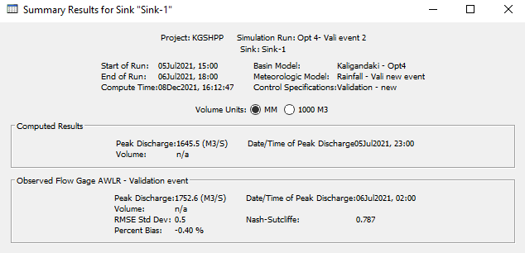
Figure 2-14 Summary table for the validation event
- PMF simulation
Case 1: PMP observed at both Baglung and Jomsom station
For simulating PMF, the highest point PMP value calculated using Hershfield’s method (as given in Chapter 1) of given the stations was selected and added in the meteorological model. The selected 24- hr PMP value for station Baglung (605) is 467.9 mm and for station Jomsom (601) is 448.1 mm. Both the station was assumed to generate maximum precipitation during the time of the model run.
The point rainfall value for both the stations was distributed using temporal distribution pattern adopted in Table 1-3. The control specification has been set to run for two days with time interval of 3 hours so that the PMF flow hydrograph components that includes rising limb and recession can be visualized. The peak outflow observed at the outlet of the basin is 33,894.0 m³/s.
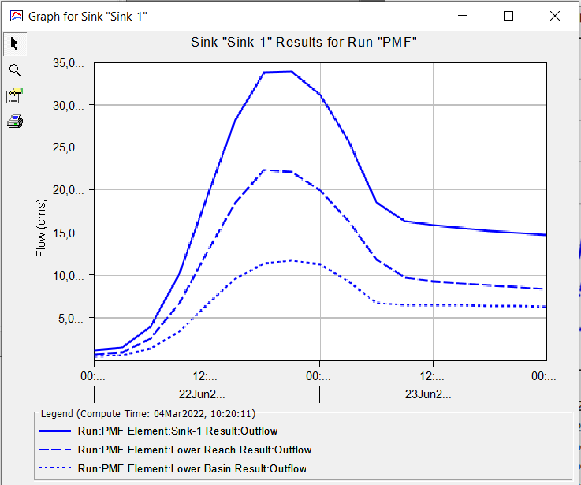
Figure 2-15 Flow hydrograph for PMF estimation with max precipitation recorded in both station Baglung and Jomsom
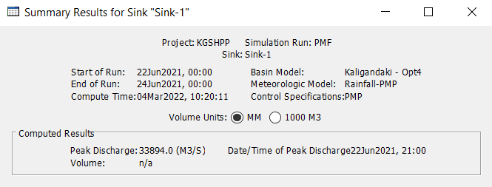
Figure 2-16 Summary table for the PMF estimation with max precipitation recorded in both station Baglung and Jomsom

Case 1: PMP observed at only Baglung station
In this case, it is assumed that the PMP is received only at station Baglung but Jomsom receives annual average rainfall only which is 260.13 mm for period from 1957-2011. The temporal distribution for the annual average point precipitation recorded in Jomsom station is calculated using the same method as in Table 1-3. Other model parameters and control specification is kept same as before.
The peak outflow observed at the outlet of the basin is 24,096.9 m³/s.
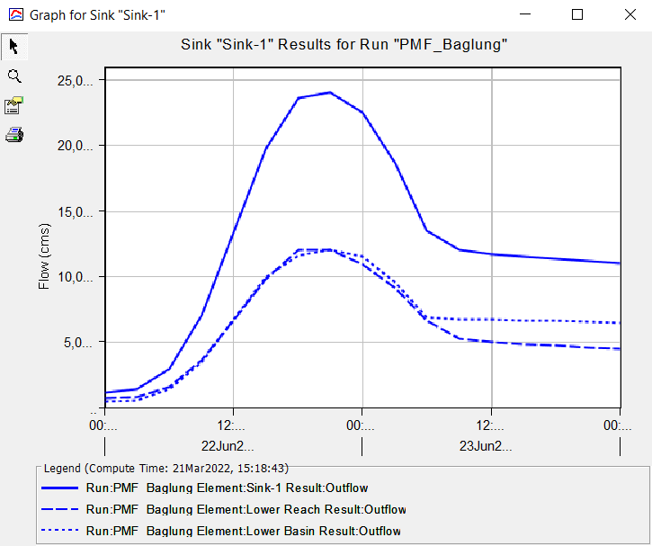
Figure 2-17 Flow Hydrograph for PMF estimation with max precipitation recorded only in station Baglung
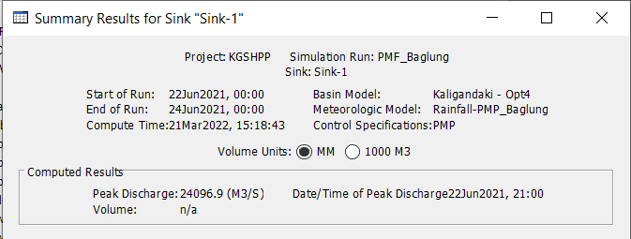
Figure 2-18 Summary Table for PMF estimation with max precipitation recorded only in station Baglung

Discussion
The peak discharge and apex time are obtained after computing the unit hydrograph for given maximum precipitation. Having peak discharge computed, it is possible to evaluate and draw the flood's hydrograph resulting from the probable maximum precipitation.
Regarding the investigation, the above-calculated PMF value on outlet in Case I with maximum probable precipitation received in both Baglung and Jomsom station seems overestimated if compared with the PMF estimates in the same region. Successful estimation of PMF is made in Kaligandaki A Hydropower Project which is 12,126 m³/s.
A number of investigators have obtained information on the largest recorded floods in history from tens of thousands of stream flow gauging stations around the world. They have then fitted envelop curves to the maximum recorded flows. Since there are so many stations in the historical record it is considered that the envelope curves are likely to approach the PMF values. Any PMF estimate that sits well above or well below these curves can be considered with suspicion. These envelope curves is provided in Figure 2-19.
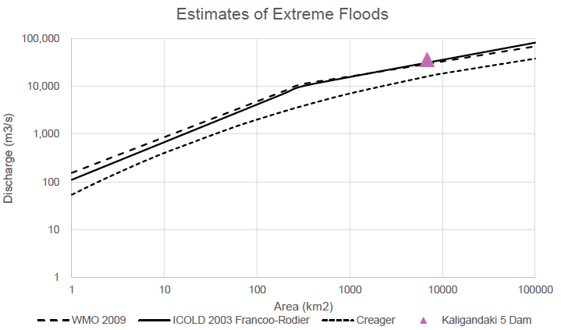
Figure 2-19 World’s Largest Floods Envelope Curves
It can be seen that the estimate of 33,894.0 m³/s for the PMF at Kaligandaki 5 Dam sits on the envelope curve when plotted against a catchment area of 6,828 km² which is plausible but not reasonable as suggestion from the adopted PMF value used in Kaligandaki-A Hydropower Project and from generalised formula derived from regional PMF estimate.
Also, the HEC-HMS model result from allowing only the station Baglung to receive PMP but Jomsom to receive annual average rainfall value suggest that the PMF received in the outlet of the basin is 24,096.9 m³/s which is still on the higher side.
Thus, it is suggested that the PMF value for the hydraulic design be rationally selected as 11,100 m³/s based on the regional estimate using historical records and adopted value at KG-A Hydropower Project.
It is expected that the coarseness of data available for rainfall-discharge is the limitation of the model.

Annex

Calibration Event Data
Table 3-1 Selected data in the model for calibration event
Time | Baglung - Preicipitation (mm) | Jomsom - Precipitation (mm) | Stage at AWLR (m) | Discharge at AWLR (cumecs)
6/14/21 12:00 AM | 0.20 | 0.40 | 3.85 | 1542.36
6/14/21 1:00 AM | 0.00 | 0.00 | 4.06 | 1683.79
6/14/21 2:00 AM | 0.20 | 0.00 | 4.20 | 1782.13
6/14/21 3:00 AM | 0.00 | 0.00 | 4.19 | 1773.02
6/14/21 4:00 AM | 0.00 | 0.00 | 4.09 | 1706.01
6/14/21 5:00 AM | 0.00 | 0.00 | 3.97 | 1623.66
6/14/21 6:00 AM | 0.00 | 0.00 | 3.80 | 1510.81
6/14/21 7:00 AM | 0.00 | 0.00 | 3.71 | 1446.01
6/14/21 8:00 AM | 0.40 | 0.00 | 3.61 | 1386.13
6/14/21 9:00 AM | 0.20 | 0.00 | 3.56 | 1356.41
6/14/21 10:00 AM | 0.00 | 0.00 | 3.55 | 1345.94
6/14/21 11:00 AM | 0.00 | 0.00 | 3.50 | 1318.33
6/14/21 12:00 PM | 0.20 | 0.00 | 3.65 | 1411.73
6/14/21 1:00 PM | 2.40 | 0.00 | 3.78 | 1492.90
6/14/21 2:00 PM | 4.60 | 0.00 | 3.82 | 1522.65
6/14/21 3:00 PM | 15.80 | 3.60 | 3.79 | 1499.55
6/14/21 4:00 PM | 6.20 | 3.20 | 3.77 | 1490.50
6/14/21 5:00 PM | 5.20 | 2.80 | 3.84 | 1533.32
6/14/21 6:00 PM | 12.40 | 2.00 | 4.16 | 1749.65
6/14/21 7:00 PM | 9.80 | 8.60 | 4.52 | 2011.38
6/14/21 8:00 PM | 12.00 | 9.00 | 4.52 | 2009.54
6/14/21 9:00 PM | 8.60 | 0.80 | 5.03 | 2397.90
6/14/21 10:00 PM | 3.60 | 0.40 | 5.53 | 2804.81
6/14/21 11:00 PM | 5.80 | 1.80 | 5.66 | 2915.89
6/15/21 12:00 AM | 2.20 | 1.00 | 5.75 | 2992.32
6/15/21 1:00 AM | 1.60 | 1.40 | 5.47 | 2750.12
6/15/21 2:00 AM | 1.80 | 0.20 | 5.28 | 2599.98
6/15/21 3:00 AM | 5.40 | 0.40 | 5.12 | 2465.51
6/15/21 4:00 AM | 12.00 | 1.80 | 5.02 | 2389.23
6/15/21 5:00 AM | 6.80 | 1.40 | 4.94 | 2326.09
6/15/21 6:00 AM | 5.60 | 2.20 | 4.94 | 2323.10
6/15/21 7:00 AM | 6.80 | 2.40 | 4.96 | 2342.85
6/15/21 8:00 AM | 7.40 | 1.20 | 5.02 | 2385.82
6/15/21 9:00 AM | 15.00 | 2.20 | 5.16 | 2504.14
6/15/21 10:00 AM | 9.60 | 3.40 | 5.32 | 2627.01
6/15/21 11:00 AM | 8.40 | 4.20 | 5.69 | 2937.06
6/15/21 12:00 PM | 12.40 | 4.60 | 5.93 | 3146.33
6/15/21 1:00 PM | 8.60 | 1.40 | 6.13 | 3325.30
6/15/21 2:00 PM | 12.60 | 3.40 | 6.30 | 3482.10
6/15/21 3:00 PM | 6.00 | 1.40 | 6.39 | 3560.49
6/15/21 4:00 PM | 9.20 | 0.00 | 6.46 | 3622.70
6/15/21 5:00 PM | 10.20 | 0.20 | 6.41 | 3582.31
6/15/21 6:00 PM | 19.40 | 1.00 | 6.39 | 3560.03
6/15/21 7:00 PM | 5.80 | 0.80 | 6.53 | 3693.90
6/15/21 8:00 PM | 0.60 | 0.40 | 6.41 | 3580.77
6/15/21 9:00 PM | 3.80 | 0.20 | 6.21 | 3394.45
6/15/21 10:00 PM | 0.80 | 0.20 | 6.09 | 3286.84
6/15/21 11:00 PM | 1.80 | 0.00 | 5.94 | 3158.32
6/16/21 12:00 AM | 6.60 | 0.20 | 5.85 | 3076.62
6/16/21 1:00 AM | 5.40 | 1.00 | 5.69 | 2936.20
6/16/21 2:00 AM | 2.20 | 0.60 | 5.61 | 2875.29
6/16/21 3:00 AM | 2.60 | 0.20 | 5.65 | 2901.43
6/16/21 4:00 AM | 2.00 | 0.20 | 5.63 | 2885.03
6/16/21 5:00 AM | 4.00 | 0.40 | 5.39 | 2687.05
6/16/21 6:00 AM | 3.20 | 0.40 | 5.29 | 2608.52
6/16/21 7:00 AM | 2.20 | 0.20 | 5.08 | 2439.67
6/16/21 8:00 AM | 4.20 | 0.20 | 5.09 | 2444.04
6/16/21 9:00 AM | 6.60 | 0.80 | 4.96 | 2345.85
6/16/21 10:00 AM | 3.00 | 0.40 | 5.04 | 2401.44
6/16/21 11:00 AM | 1.00 | 0.00 | 4.95 | 2331.80
6/16/21 12:00 PM | 3.40 | 0.00 | 4.91 | 2300.60
6/16/21 1:00 PM | 0.80 | 0.00 | 4.94 | 2330.50
6/16/21 2:00 PM | 1.20 | 0.00 | 4.85 | 2259.25
6/16/21 3:00 PM | 0.20 | 0.00 | 4.88 | 2283.29
6/16/21 4:00 PM | 0.00 | 0.00 | 4.86 | 2266.43
6/16/21 5:00 PM | 0.00 | 0.20 | 4.78 | 2200.79
6/16/21 6:00 PM | 0.00 | 0.60 | 4.66 | 2112.24
6/16/21 7:00 PM | 0.00 | 0.60 | 4.59 | 2057.42
6/16/21 8:00 PM | 0.00 | 1.00 | 4.53 | 2018.13
6/16/21 9:00 PM | 0.00 | 0.00 | 4.43 | 1942.61
6/16/21 10:00 PM | 0.00 | 0.00 | 4.34 | 1878.24
6/16/21 11:00 PM | 0.00 | 0.00 | 4.29 | 1844.01
6/17/21 12:00 AM | 0.00 | 0.00 | 4.25 | 1815.08

Validation Event Data
Table 3-2 Model selected data for validation event
Date | Baglung - Preicipitation (mm) | Jomsom - Precipitation (mm) | Stage at AWLR (m) | Discharge at AWLR (cumecs)
7/5/21 15:00 | 0.6 | 0 | 2.94 | 937.86
7/5/21 16:00 | 3.4 | 0 | 2.95 | 939.86
7/5/21 17:00 | 1.2 | 0 | 3.02 | 978.49
7/5/21 18:00 | 24.6 | 0 | 3.42 | 1211.46
7/5/21 19:00 | 12.8 | 0 | 3.71 | 1389.41
7/5/21 20:00 | 8.6 | 0.2 | 3.78 | 1437.62
7/5/21 21:00 | 2.2 | 0.2 | 4.13 | 1671.58
7/5/21 22:00 | 0.6 | 0 | 4.15 | 1679.33
7/5/21 23:00 | 0.2 | 0 | 4.15 | 1684.82
7/6/21 0:00 | 0 | 0 | 4.13 | 1666.91
7/6/21 1:00 | 0 | 0 | 4.20 | 1715.90
7/6/21 2:00 | 0 | 0 | 4.25 | 1752.55
7/6/21 3:00 | 0 | 0 | 4.14 | 1675.11
7/6/21 4:00 | 0 | 0 | 3.95 | 1546.56
7/6/21 5:00 | 0 | 0 | 3.80 | 1449.13
7/6/21 6:00 | 0 | 0 | 3.67 | 1362.93
7/6/21 7:00 | 0 | 0 | 3.56 | 1298.77
7/6/21 8:00 | 0 | 0 | 3.49 | 1252.37
7/6/21 9:00 | 0 | 0 | 3.41 | 1207.95
7/6/21 10:00 | 0 | 0 | 3.37 | 1182.99
7/6/21 11:00 | 0 | 0 | 3.31 | 1147.60
7/6/21 12:00 | 0 | 0 | 3.29 | 1135.83
7/6/21 13:00 | 0 | 0 | 3.28 | 1127.14
7/6/21 14:00 | 0 | 0 | 3.34 | 1162.67
7/6/21 15:00 | 0 | 0 | 3.35 | 1169.39
7/6/21 16:00 | 0 | 0 | 3.36 | 1176.73
7/6/21 17:00 | 0 | 0 | 3.36 | 1173.16
7/6/21 18:00 | 0 | 0 | 3.41 | 1206.64

